 | Teacher Assembly | Children’s assembly | Rev John Assembly | Aims
Week 1  8.4.24 | Perseverance  Teacher: Stuart | Perseverance  https://www.assemblies.org.uk/pri/1867/dont-be-afraid-to-ask | Aims: Perseverance | To promote a spirit of enquiry and encourage confidence about asking questions.  To research the life of Greta Thunberg  To explore Autism Awareness Month and what this means  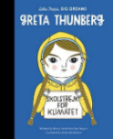  Music: Derek Paravincini playing Sealed Door composed by Nobuo Uematsu.  Book Focus: Greta Thunberg  https://www.youtube.com/watch?v=OpKjF5AF7TQ
Week 2  15.4.24 | Respect  https://www.assemblies.org.uk/pri/3836/planet-protectors  Teacher: Tom | Respect  https://www.assemblies.org.uk/sec/2911/caring-for-the-earth | Aims: Respect for our world | Earth Day (March 22nd)  To consider our relationship with our planet and what we can do to help protect it.  To encourage us to have hopes and dreams for our future and our world.  To understand that to achieve one's dream will always at some point require a struggle.  To discuss the struggles our beautiful earth is facing  Book Focus: Greta and the Giants  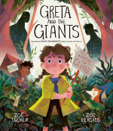  Music: Rutter: For The Beauty Of The Earth https://www.youtube.com/watch?v=K-fcOgBTs4M
Week 3  22.4.23 | Trust  https://www.natgeokids.com/uk/discover/science/general-science/albert-einstein-facts/ Teacher: Nikki | Trust  https://www.assemblies.org.uk/pri/809/trust | Aims: Trust | Autism Awareness Month  Albert Einstein  To learn about the life of albert einstein  To encourage students to consider the value of random thoughts  To discuss the values needed to help us reach success.  To help children think about trust and who they depend on to help them in difficult times.  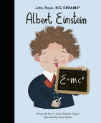  Music: Nocturne in B-flat Minor – Chopin, played by Lucy  https://www.youtube.com/watch?v=WWFJ39nn6Rw
Week 4  29.4.24 | Truthfulness  https://www.assemblies.org.uk/pri/4137/a-stormy-problem  Teacher: Stuart | Truthfulness  https://www.assemblies.org.uk/pri/3742/always-there | Aims: Truthfulness | To explore Mental Health Awareness Month  To consider how the weather can be used as a metaphor for how we feel and the problems that we face.  To encourage us to trust in God in difficult situations.  Book Focus: Rain before Rainbows  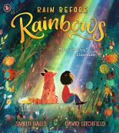  Music: Walking on Sunshine – Katrina and the Waves  https://www.youtube.com/watch?v=qK5KhQG06xU
Week 5  6.5.24 | Truthfulness  https://www.assemblies.org.uk/pri/3166/our-responsibility-to-the-earth  Teacher: Tom | Truthfulness  https://www.assemblies.org.uk/pri/270/from-the-tiny-ant | Aims: Truthfulness | David Attenborough’s Birthday  (May 8th)  To encourage us to take responsibility for looking after the environment.  To explore the life and work of David Attenborough.  To reflect on protecting endangered animals with reference to the story of Noah.  To show that we share our neighbourhood with wildlife and that by dropping litter we can harm birds and animals.  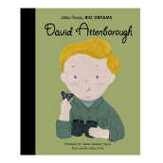  Music: Saint-Saëns - The Carnival of the Animals - Swan https://www.youtube.com/watch?v=3qrKjywjo7Q
Week 6  13.5.24 | Spirituality  https://www.assemblies.org.uk/pri/3575/pause-for-thought-can-you-remember  Teacher: Nikki | Spirituality  https://www.assemblies.org.uk/pri/677/memories | Aims: Spirituality | To consider the importance of our memories.  Dementia Action Week  The Tide  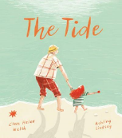  Music: Elaine Paige – Memory  https://www.youtube.com/watch?v=ScXZnXz_7mg
Week 7  20.5.24 | Pentecost  https://www.assemblies.org.uk/pri/1962/pentecost  Teacher: Nikki | Pentecost  https://www.assemblies.org.uk/pri/102/islam--religion-of-peace | Aims: Pentecost | World Day for Cultural Diversity (21.05)  To explore the roots and essential teaching of Islam.  To explore the christian festival of pentescoste  Book Focus: Not Now Noori  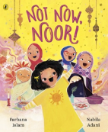  Music: Lut Gaaye By Yumna Ajin https://www.youtube.com/watch?v=axrgKssKMmg

